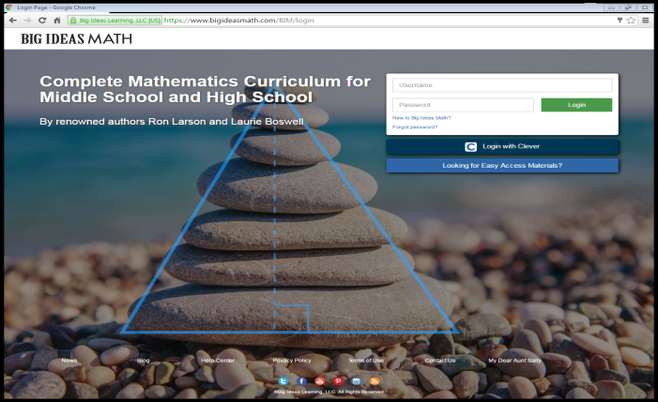**Directions to Access Online Textbook**

Log On to [www.bigideasmath.com](http://www.bigideasmath.com)

Click New to Big Ideas

Sign in using this Access Code:

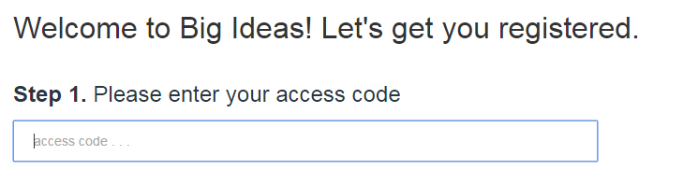

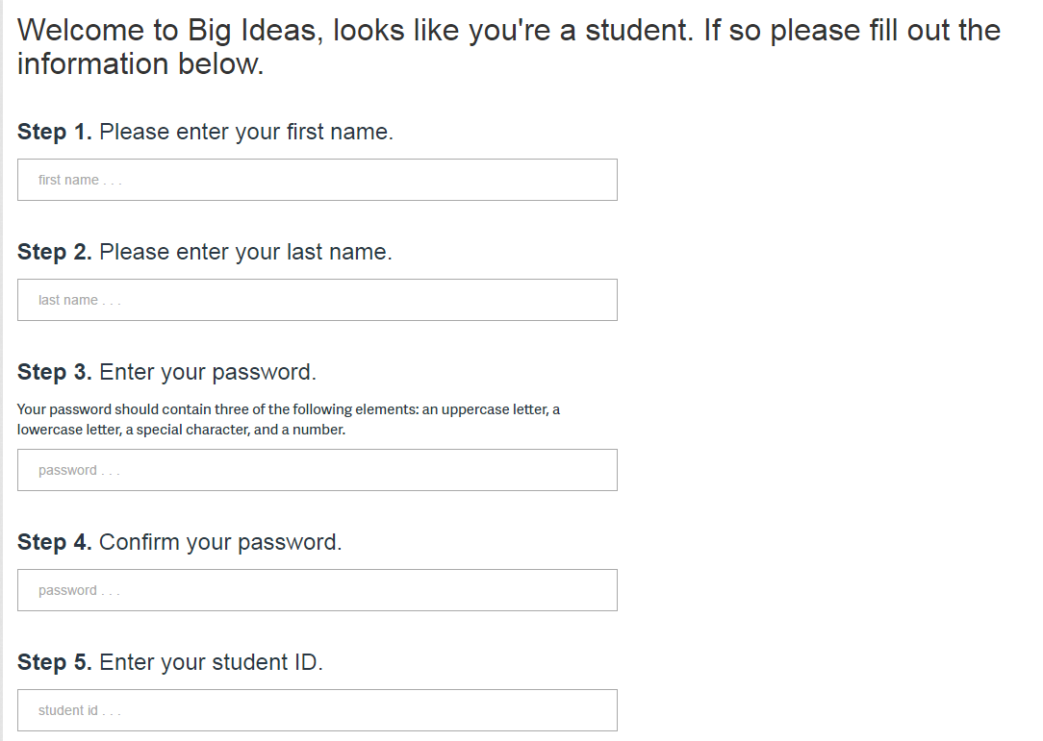Fill out the forms

**For your password use:**  
First three letters of first name + student ID

(Must be 8 characters)

Example:

The012345

Click next, it will give you your username (write it down).

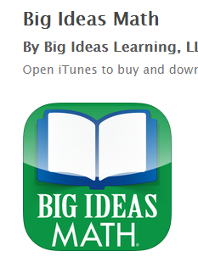Go back to [www.bigideasmath.com](http://www.bigideasmath.com)

Sign In with username and password

**\*\*FOR PHONES**

In app store search for BIG IDEAS MATH, download it, sign in! The book will be on your phone!